PROJECT REPORT
Streamlining IT Procurement: Automating Standard Laptop Orders with Flow Designer
Team 12
Logesh M (Team Lead)
Indu R
Naveen Kumar J
Porulselvan M

1. INTRODUCTION

1.1 Project Overview
This project automates the ordering of standard employee laptops using Flow Designer. Today the process is handled manually through a mix of emails, spreadsheets and manual ticketing, which makes it slow and error-prone.
With the proposed solution, an employee submits a request through a standard laptop catalog form with pre-filled details. Flow Designer routes the request to the manager for approval, sends reminders and escalates if there is no response, checks stock and syncs with asset management, creates the procurement task and the purchase request to the vendor, and keeps the employee informed with live status and notifications at every stage.

1.2 Purpose
The purpose of the project is to replace a manual, fragmented ordering process with a single automated workflow. The main goals are:
- Faster approvals: automatic routing, reminders and escalation so requests do not stall in email inboxes.
- Fewer errors: no manual copy-paste of hardware specs and user details, so orders and shipments are correct.
- Full visibility: applicants and managers can track the order status without raising “Where is my laptop?” tickets.
- Inventory in sync: orders are linked to asset management to avoid stock shortages and duplicate purchases.

2. IDEATION PHASE

2.1 Problem Statement
The current IT procurement process for ordering standard employee laptops is manual, slow and prone to errors. Because it relies on emails, spreadsheets and manual ticketing, it suffers from these bottlenecks:
- Delayed approvals: requests stall in email inboxes due to a lack of automated routing and reminders.
- Data entry errors: IT staff copy-paste hardware specs and user details by hand, leading to incorrect orders and shipping mistakes.
- Zero visibility: applicants and managers cannot track order status, causing many “Where is my laptop?” support tickets.
- Inventory inefficiencies: orders are not synced with asset management, leading to stock shortages or duplicate purchases.
The problem is captured from the customer’s point of view in two customer problem statements:
Problem Statement | I am (Customer) | I’m trying to | But | Because | Which makes me feel
PS-1 | An employee (applicant) who needs a standard laptop | Order a standard laptop and track its approval and delivery | My request stalls in email approvals and I cannot see my order status | The process is manual, with no automated routing, reminders or status updates | Frustrated and uncertain, as I keep asking “Where is my laptop?”
PS-2 | An IT procurement staff member who processes laptop orders | Place accurate laptop orders and keep stock in sync with asset records | I copy-paste specs and user details by hand and cannot check stock easily | Orders are not connected to asset management and rely on manual data entry | Stressed and worried about wrong orders, shipping mistakes and duplicate purchases

2.2 Empathy Map Canvas
The empathy map captures what the employee (applicant) ordering a standard laptop thinks and feels, hears, sees, says and does, along with the pains and gains.
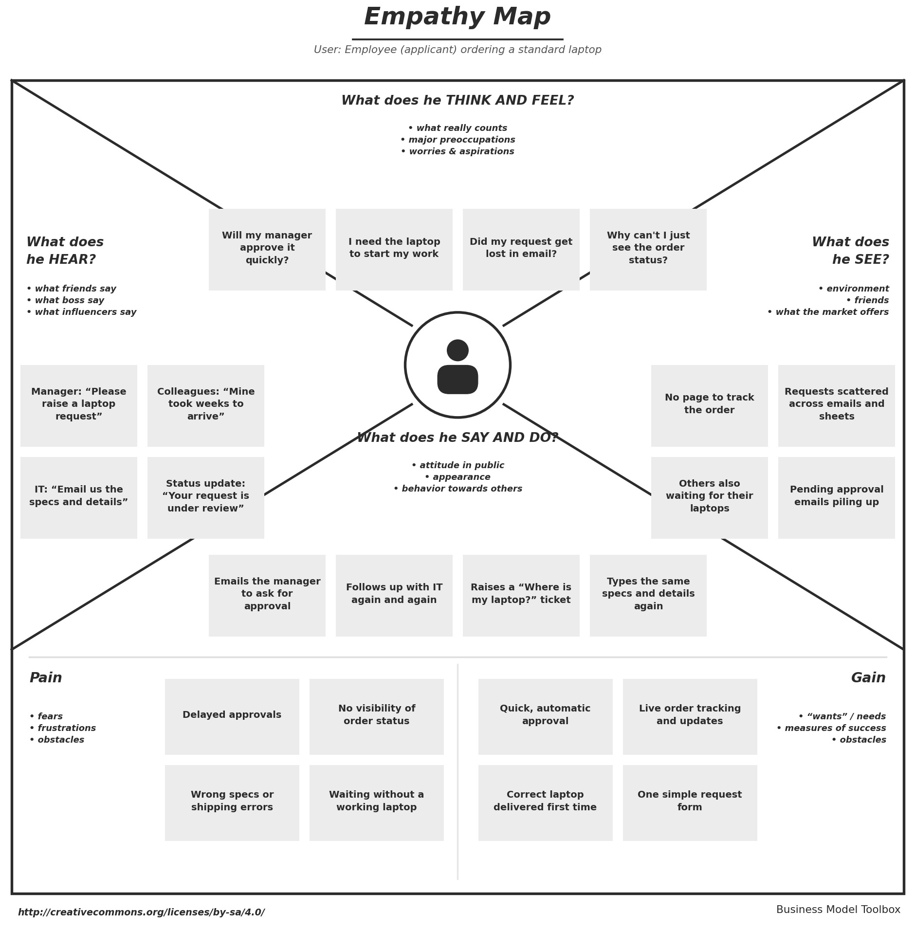
Figure 1: Empathy map of the employee (applicant)

2.3 Brainstorming
Team 12 (Logesh M, Indu R, Naveen Kumar J and Porulselvan M) brainstormed using the “How might we” approach. The problem statement was framed, each member listed ideas, similar ideas were grouped into clusters, and the ideas were prioritized on an importance versus feasibility grid.
Problem statement (How might we): How might we automate standard laptop ordering with Flow Designer so that approvals are fast, order data is error-free, status is visible to everyone, and inventory stays in sync with asset management?
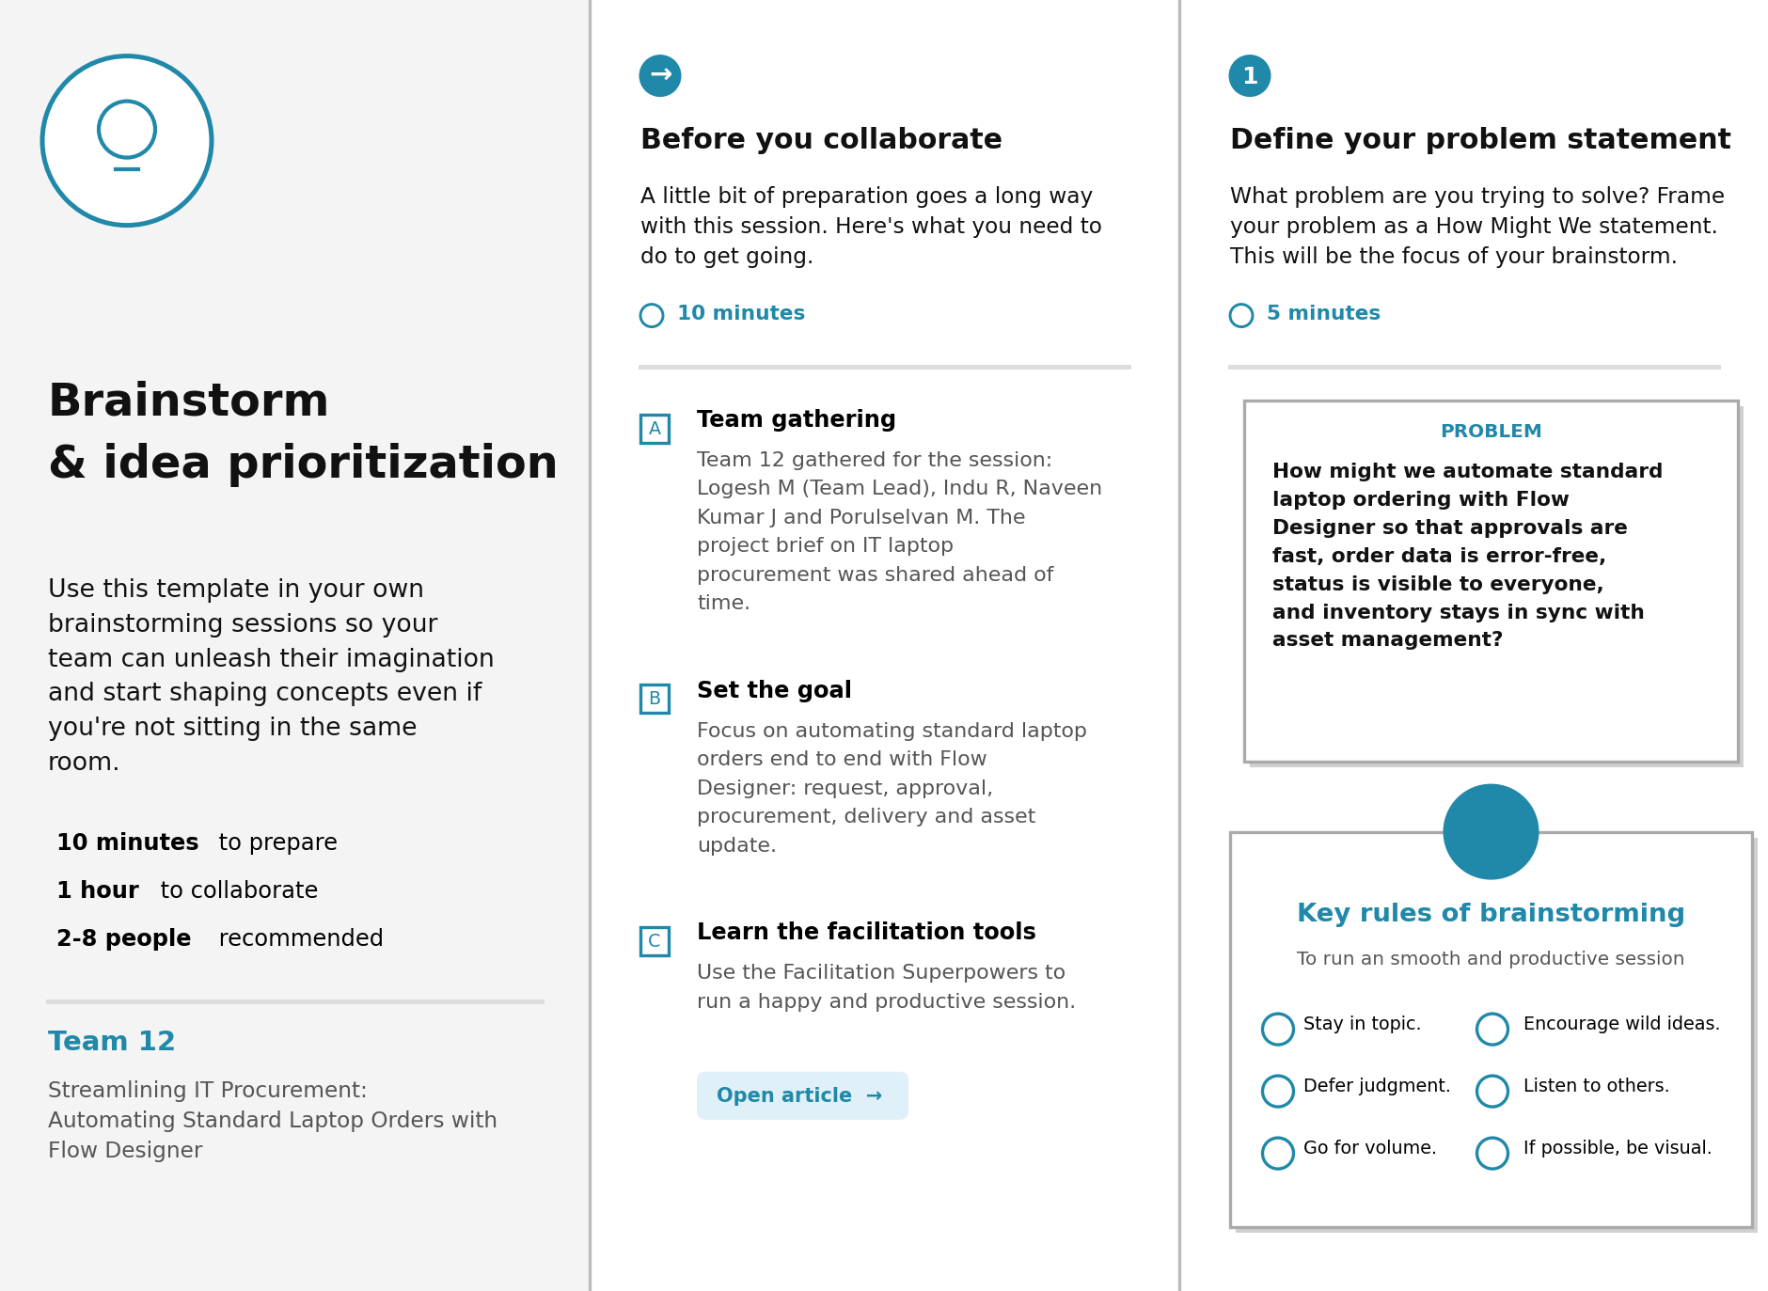
Figure 2: Step 1 – Team gathering, collaboration and problem statement
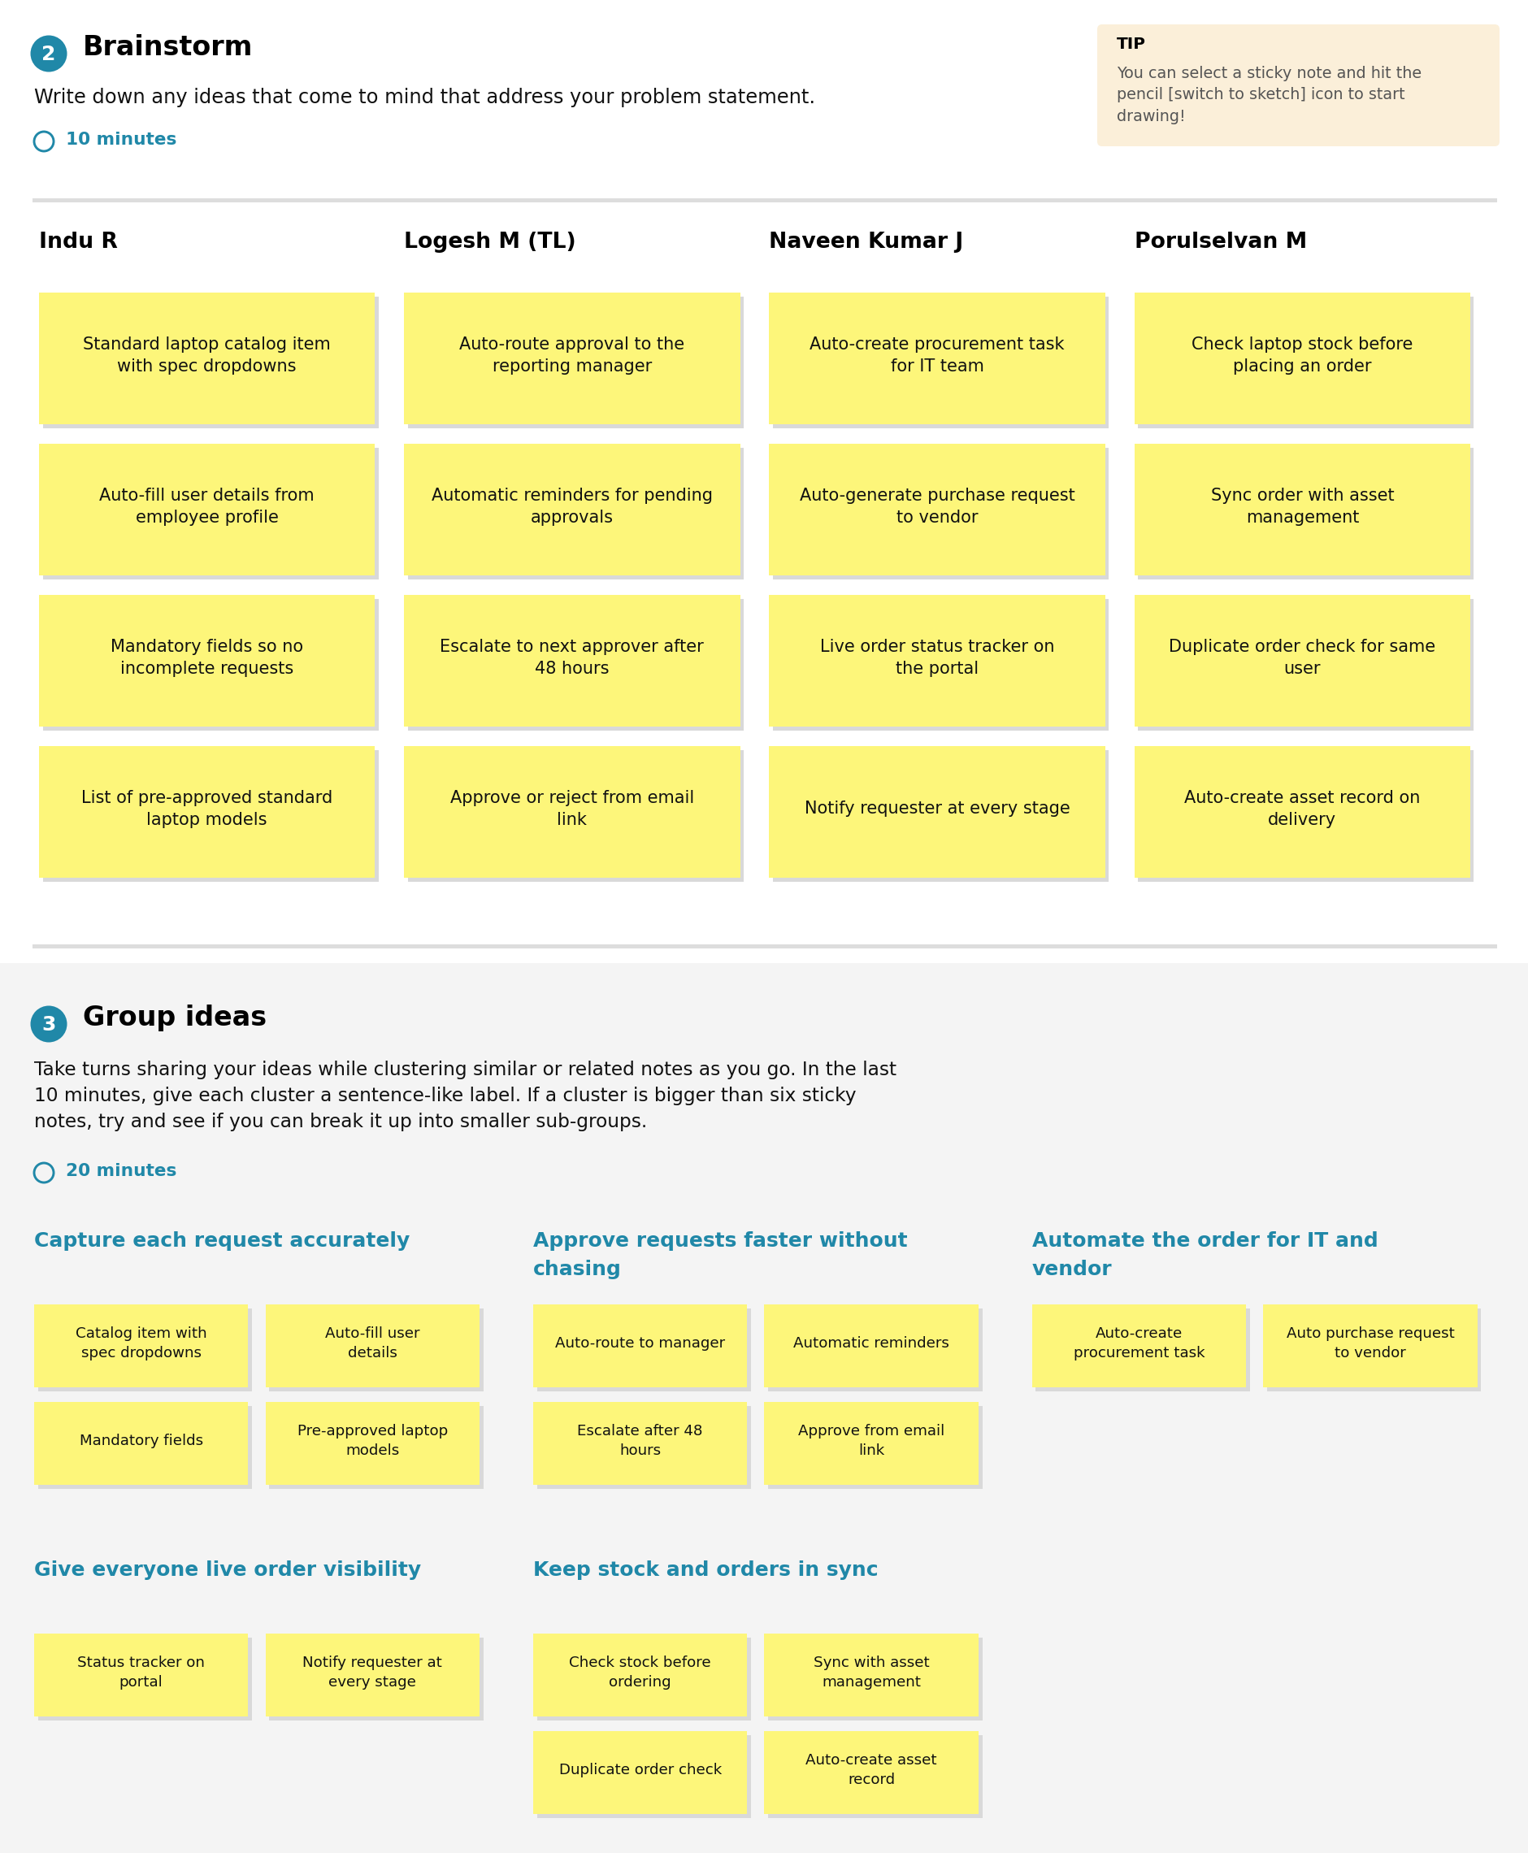
Figure 3: Step 2 – Brainstorm, idea listing and grouping
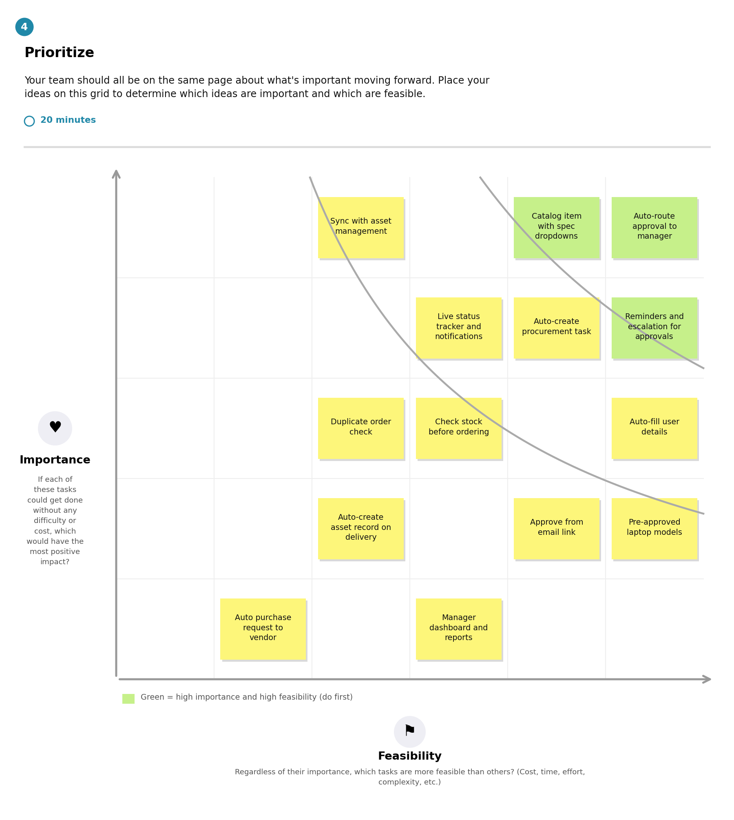
Figure 4: Step 3 – Idea prioritization
The ideas with the highest importance and feasibility, such as automatic approval routing, the catalog form with spec dropdowns, reminders and escalation, and automatic procurement task creation, were chosen for the first sprints.

3. REQUIREMENT ANALYSIS

3.1 Customer Journey map
The journey below follows an employee who needs a standard laptop, showing the current experience and how the proposed solution improves each stage.
Stage | Employee action | Touchpoint | Feeling today | Pain point today | With the proposed solution
1. Need | Realizes a new or replacement laptop is needed | Manager, IT desk | Hopeful | Not sure which model or process to follow | Approved standard models are listed in the catalog
2. Request | Emails the manager or IT with specs and details | Email, spreadsheet | Annoyed | Details are typed again and again; mistakes creep in | One catalog form with pre-filled details and validation
3. Approval | Waits for the manager to approve | Email inbox | Anxious | Request stalls with no reminders or escalation | Automatic routing, reminders and escalation after 48 hours
4. Procurement | Waits for IT to check stock and order | Ticket, spreadsheet | Frustrated | Stock not checked against assets; risk of duplicate orders | Automatic stock check, asset sync and purchase request to the vendor
5. Delivery and tracking | Asks “Where is my laptop?” | Phone, email, support ticket | Uncertain | No visibility of order status | Live status tracker and notifications at every stage
6. Receive | Gets the laptop | IT desk | Relieved | Delivery often delayed or incorrect | Correct laptop delivered; asset record created automatically

3.2 Solution Requirement
Functional requirements
FR No. | Functional Requirement (Epic) | Sub Requirement (Story / Sub-Task)
FR-1 | Laptop Request Submission | Request through a service catalog form  Select standard laptop model and specifications  Auto-fill user details from employee profile  Validation of mandatory fields before submission
FR-2 | Approval Workflow | Automatic routing to the reporting manager  Approve or reject from portal or email  Automatic reminders for pending approvals  Escalation to next approver if no response in 48 hours
FR-3 | Procurement Automation | Auto-create procurement task with specs and user details  Auto-generate purchase request to vendor for out-of-stock laptops
FR-4 | Inventory and Asset Sync | Stock check before placing an order  Sync order with asset management  Duplicate order check  Auto-create asset record on delivery
FR-5 | Order Tracking and Notifications | Live order status tracker for applicant and manager  Confirmation email on submission  Notification at every status change
FR-6 | Reporting and Administration | Dashboard of pending, approved and delivered requests  Admin maintains standard laptop catalog and approval rules

Non-functional requirements
NFR No. | Non-Functional Requirement | Description
NFR-1 | Usability | Simple catalog form with pre-filled details and a clear status view, so employees can order a laptop in a few clicks without training.
NFR-2 | Security | Role-based access so requesters, managers, IT staff and admins see only what they need; approvals and data changes are logged for audit.
NFR-3 | Reliability | Every request is processed consistently; failed steps are retried and logged, and no request is lost or duplicated.
NFR-4 | Performance | Request submission and routing to the approver complete within seconds, and status updates show in near real time.
NFR-5 | Availability | Request and tracking are available 24x7 on the platform, with planned maintenance outside business hours.
NFR-6 | Scalability | Handles growth in employees and requests, and new laptop models, approval rules or hardware items can be added without redesigning the flow.

3.3 Data Flow Diagram
The Level 0 data flow diagram shows how data moves between the external entities (Employee, Manager, IT Procurement Team and Vendor), the four processes and the two data stores.
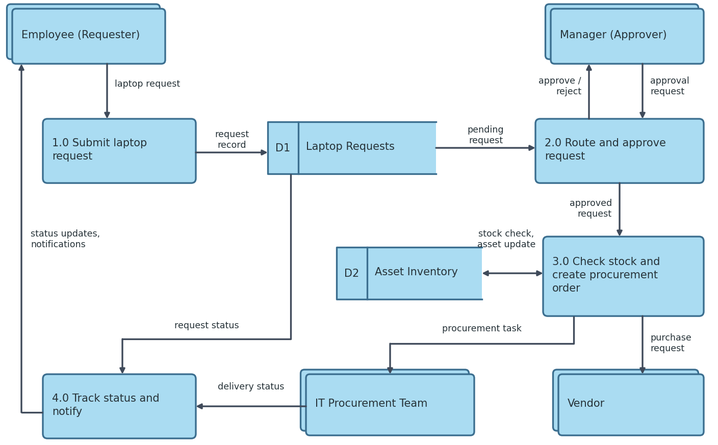
Figure 5: Data flow diagram (Level 0)
- 1.0 Submit laptop request: receives the request from the employee and stores it in Laptop Requests (D1).
- 2.0 Route and approve request: sends the approval request to the manager and receives approve or reject.
- 3.0 Check stock and create procurement order: checks and updates Asset Inventory (D2), then sends the procurement task to the IT team and the purchase request to the vendor.
- 4.0 Track status and notify: collects the request and delivery status and sends status updates and notifications to the employee.

3.4 Technology Stack
Table 1: Components and technologies
S.No | Component | Description | Technology
1 | User Interface | Employee submits and tracks the request; manager approves or rejects it. | ServiceNow Service Portal (HTML, CSS, JavaScript, AngularJS)
2 | Application Logic-1 | Request submission: catalog item, auto-fill of user details, field validation. | ServiceNow Service Catalog, Catalog Client Scripts (JavaScript)
3 | Application Logic-2 | Approval: routes to manager, sends reminders, escalates after 48 hours. | ServiceNow Flow Designer (flow and approval actions)
4 | Application Logic-3 | Fulfilment: creates procurement task and purchase request, sends notifications. | Flow Designer actions and subflows, Notifications
5 | Database | Stores requests, approvals, tasks and user records. | ServiceNow relational database (sc_request, sc_task, sys_user)
6 | Cloud Database | Database service hosted on the cloud with the instance. | ServiceNow cloud-hosted instance database
7 | File Storage | Attachments such as quotations and delivery proof. | ServiceNow attachment storage (sys_attachment)
8 | External API-1 | Sends purchase requests to the vendor for out-of-stock laptops. | Vendor REST API via IntegrationHub
9 | External API-2 | Sends confirmation and status emails. | Email service (SMTP)
10 | Machine Learning Model | Not used, as the solution is rule-based automation. | Not applicable
11 | Infrastructure (Server / Cloud) | Deployed on the cloud, not on a local system. Local server: not required. Cloud server: ServiceNow instance. | Cloud (ServiceNow instance)

Table 2: Application characteristics
S.No | Characteristics | Description | Technology
1 | Open-Source Frameworks | Open-source frameworks and libraries used for the portal user interface. | AngularJS, Bootstrap (Service Portal)
2 | Security Implementations | Role-based access control and ACLs, single sign-on login, encrypted communication and audit logs of approvals and changes. | ServiceNow roles and ACLs, SSO (SAML), HTTPS / TLS, OWASP guidelines
3 | Scalable Architecture | Multi-tier architecture (UI, application and database tiers); new catalog items and approval rules are added through configuration. | ServiceNow 3-tier architecture, Flow Designer subflows
4 | Availability | Application runs on the cloud platform with redundant data centers and failover; maintenance is planned outside business hours. | ServiceNow cloud with primary and secondary data centers
5 | Performance | Flows run asynchronously, queries use indexed fields, and dashboards give quick status views without manual reports. | Flow Designer asynchronous execution, indexed tables, reports and dashboards

4. PROJECT DESIGN

4.1 Problem Solution Fit
The Problem–Solution Fit canvas checks that the solution matches the customer’s problem, constraints and behaviour. It confirms that the customers are employees, managers and IT staff, that the root cause is a manual process with no automated routing or asset link, and that the proposed Flow Designer workflow fits their behaviour and channels.
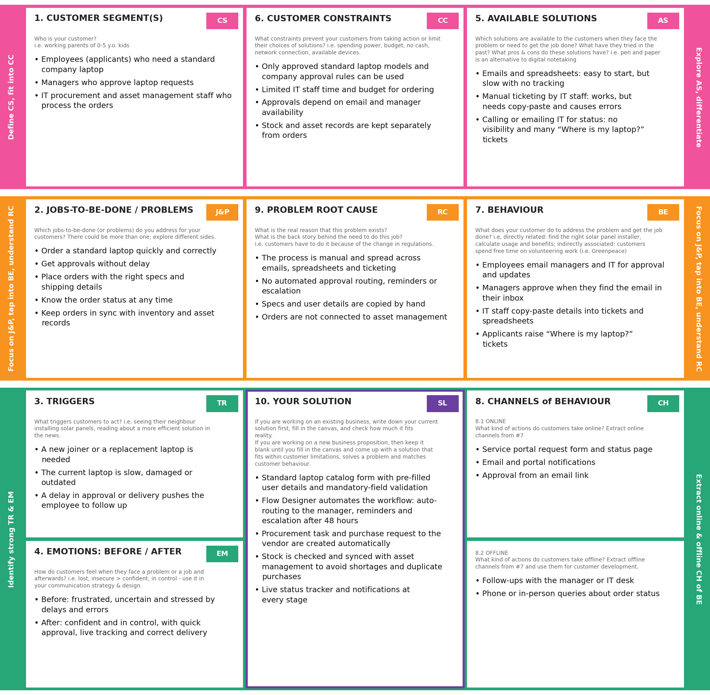
Figure 6: Problem–Solution Fit canvas

4.2 Proposed Solution
S.No. | Parameter | Description
1 | Problem Statement (Problem to be solved) | The current process for ordering standard employee laptops is manual, slow and error-prone. It relies on a mix of emails, spreadsheets and manual ticketing, which causes delayed approvals, data entry errors, zero visibility of order status (many “Where is my laptop?” tickets) and inventory inefficiencies such as stock shortages or duplicate purchases.
2 | Idea / Solution description | Automate the standard laptop ordering process end to end with Flow Designer. The employee submits a request through a catalog form with pre-filled details. The request is routed automatically to the manager for approval, with reminders and escalation. After approval, stock is checked and synced with asset management, and a procurement task and purchase request are created. The employee tracks live status and gets notifications at every stage.
3 | Novelty / Uniqueness | Replaces fragmented emails, spreadsheets and manual tickets with one automated workflow. Approval routing, stock check against asset management, procurement and live status tracking are combined in a single low-code flow, with no manual copy-paste of specs and user details.
4 | Social Impact / Customer Satisfaction | Employees receive laptops faster and no longer need to chase approvals or raise “Where is my laptop?” tickets. Managers approve with a single action, and IT staff spend less time on repetitive data entry and corrections. Accurate orders and clear status improve satisfaction, and avoiding duplicate purchases reduces waste.
5 | Business Model (Revenue Model) | This is an internal enterprise solution, so there is no direct revenue. The value comes from cost savings: less IT staff time spent on manual ordering, fewer ordering errors and duplicate purchases, and fewer support tickets.
6 | Scalability of the Solution | The solution runs on a cloud platform, so it can handle more employees and requests without redesign. New laptop models, approval rules and other hardware requests can be added through configuration, and the same flow can be reused for other departments or locations.

4.3 Solution Architecture
The architecture has three zones: the user side (employee and manager), the ServiceNow cloud (service portal, Flow Designer and database) and the back end or external systems (asset management, IT procurement team and vendor).
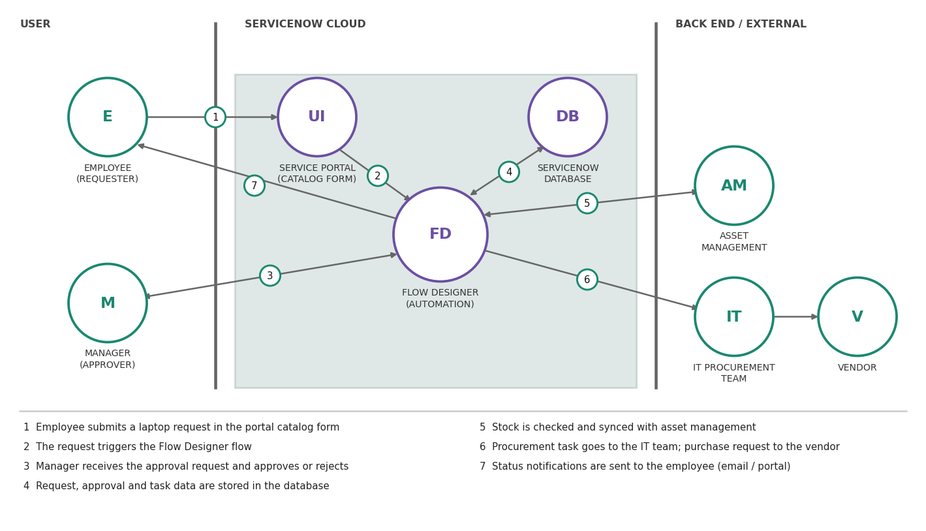
Figure 7: Solution architecture
- The employee submits a laptop request in the portal catalog form.
- The request triggers the Flow Designer flow.
- The manager receives the approval request and approves or rejects it.
- Request, approval and task data are stored in the ServiceNow database.
- Stock is checked and synced with asset management.
- The procurement task goes to the IT team and the purchase request goes to the vendor.
- Status notifications are sent to the employee by email and on the portal.

5. PROJECT PLANNING & SCHEDULING

5.1 Project Planning
The work is planned in three sprints based on the priority of the user stories. Sprint 1 delivers the request form and manager approval, Sprint 2 adds tracking, notifications and procurement, and Sprint 3 adds inventory sync and reporting.
Sprint | User Story | Functional Requirement (Epic) | User Story / Task | Priority | Release
Sprint-1 | USN-1 | Laptop Request | As an employee, I can submit a standard laptop request by selecting a laptop model in the service catalog form. | High | Sprint-1
Sprint-1 | USN-2 | Laptop Request | As an employee, I can have my name, department and location filled in automatically from my profile. | High | Sprint-1
Sprint-1 | USN-3 | Laptop Request | As an employee, I will receive a confirmation email once I have submitted my request. | Medium | Sprint-1
Sprint-1 | USN-4 | Laptop Request | As an employee, I can view the approved standard laptop models with their specifications before ordering. | Medium | Sprint-1
Sprint-1 | USN-7 | Approval | As a manager, I will automatically receive an approval request for my team member’s laptop request. | High | Sprint-1
Sprint-2 | USN-5 | Order Tracking | As an employee, I can track the status of my laptop order (approval, procurement, shipping, delivery). | High | Sprint-2
Sprint-2 | USN-6 | Notifications | As an employee, I will receive a notification whenever my request status changes. | Medium | Sprint-2
Sprint-2 | USN-8 | Procurement | As an IT staff member, I can get a procurement task created automatically with the laptop specs and user details. | High | Sprint-2
Sprint-2 | USN-10 | Approval | As a manager, I will receive automatic reminders, and the request is escalated if I do not respond in time. | Medium | Sprint-2
Sprint-2 | USN-11 | Procurement | As an IT staff member, I can have a purchase request sent to the vendor automatically for out-of-stock laptops. | Medium | Sprint-2
Sprint-3 | USN-9 | Inventory Sync | As an administrator, I can sync approved orders with asset management so that stock is checked before ordering. | High | Sprint-3
Sprint-3 | USN-12 | Reporting | As an administrator, I can view a dashboard of pending, approved and delivered laptop requests. | Low | Sprint-3
Sprint start and end dates and story points: [to be added by the team].

6. FUNCTIONAL AND PERFORMANCE TESTING

6.1 Performance Testing
The solution is rule-based automation and does not use a machine learning model, so accuracy-type metrics do not apply. Testing therefore focuses on whether each flow behaves correctly (functional testing) and whether it responds quickly enough (performance), using Flow Designer test runs with execution details, and the ServiceNow Automated Test Framework (ATF) for repeatable tests.
Test ID | Scenario | Expected result | Result
TC-1 | Submit a standard laptop request with all fields filled | Request number is generated and a confirmation email is sent | [to be filled after testing]
TC-2 | Submit a request with a mandatory field empty | Submission is blocked with a validation message | [to be filled after testing]
TC-3 | Manager approves the request | Flow continues to the stock check | [to be filled after testing]
TC-4 | Manager rejects the request | Request is closed and the employee is notified | [to be filled after testing]
TC-5 | Manager does not respond | Reminder is sent, and the request is escalated after 48 hours | [to be filled after testing]
TC-6 | Approved laptop is in stock | Stock is reserved and the procurement task is created for the IT team | [to be filled after testing]
TC-7 | Approved laptop is out of stock | Purchase request is sent to the vendor and linked to the request | [to be filled after testing]
TC-8 | Same employee requests the same laptop again | Duplicate request is flagged | [to be filled after testing]
TC-9 | Request status changes | Notification is sent and the status tracker shows the new status | [to be filled after testing]
TC-10 | Laptop is delivered | Asset record is created in asset management | [to be filled after testing]

Performance checks: submission and routing to the approver should complete within seconds, and status updates should appear in near real time (see NFR-4). Measured values: [to be filled after testing].

7. RESULTS

7.1 Output Screenshots
Screenshots of the working solution are added below.
[Insert screenshot: Standard laptop catalog request form]
Figure: Standard laptop catalog request form
[Insert screenshot: Manager approval page]
Figure: Manager approval page
[Insert screenshot: Flow Designer approval and procurement flow]
Figure: Flow Designer approval and procurement flow
[Insert screenshot: Order status tracker]
Figure: Order status tracker
[Insert screenshot: Dashboard of pending, approved and delivered requests]
Figure: Dashboard of pending, approved and delivered requests

8. ADVANTAGES & DISADVANTAGES
Advantages
- Approvals are faster because requests are routed automatically, with reminders and escalation.
- Orders are more accurate because specs and user details are not copied by hand.
- Applicants and managers can see the order status, which reduces “Where is my laptop?” tickets.
- Stock is checked and synced with asset management, which avoids shortages and duplicate purchases.
- IT staff save time on repetitive data entry and follow-ups.
- The flow can be changed through configuration and reused for other hardware requests.
Disadvantages
- The solution depends on the Flow Designer platform, so it needs the platform licence and people who know how to maintain it.
- Asset and stock data must be accurate, otherwise the stock check can give wrong results.
- The vendor integration works only if the vendor offers an API.
- Employees and managers need a short period to get used to the new process.
- The current scope covers standard laptops only.

9. CONCLUSION
The project shows how the manual, email-based process for ordering standard laptops can be replaced by one automated Flow Designer workflow. The solution addresses the four main bottlenecks: delayed approvals, data entry errors, lack of visibility and inventory inefficiencies. Employees get their laptops faster and can track their orders, managers approve with a single action, and IT staff spend less time on repetitive work and corrections. The same approach can be extended to other kinds of IT requests.

10. FUTURE SCOPE
- Extend the same flow to other hardware and software requests such as monitors, phones and software licenses.
- Approve requests from chat tools such as Microsoft Teams or Slack, and add a mobile view.
- Add reports on approval time and delivery time to find and remove delays.

11. APPENDIX
Source Code (if any): No custom source code is used. The solution is built with configuration in Flow Designer (flows, subflows, catalog item and notifications). [Add an export of the configuration if required.]
Dataset Link: Not applicable, as the solution does not use a dataset.
GitHub & Project Demo Link: [Insert GitHub link] [Insert project demo link]

